<Practice Address>

Dear <PatientName>

I want to highlight to you that you, your family and/or carer can access this free, online type 2 diabetes course; Healthy Living for people with type 2 diabetes.

Healthy Living has really good results for people who complete the course. It provides knowledge and information so that you can:

- feel confident in managing your type 2 diabetes
- reduce diabetes-related stress
- improve your health and wellbeing
- achieve and maintain a healthy weight
- feel motivated to continue making healthy lifestyle choices

It’s easy to follow and you can work at your own pace. You can even use it as a refresher course if you want to update your knowledge and has a handy search function to look up quick questions e.g. driving with diabetes.

Register today at www.healthyliving.nhs.uk or scan the QR code below.

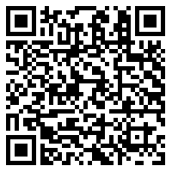

Kind regards,

<GPName>

